### **Question Set 05 Solutions**

### Psychrometrics

1. https://lh4.googleusercontent.com/klyWpGsg5Z92jKcB6ZqhxsoeOHLhdYDs25bMEdy32Yv3twOB8BTmnSIzELpAkCIsXmo-Cu2WnsO8GcoCeWdDoESACyAZZZ_nkmerefJcnaaupfcBVMlOC3W6PjwFMYPH6fEJw297dg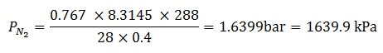https://lh3.googleusercontent.com/X5heJeh4ix3azEN5mwEf2GkzLjhfTqUWQqBg769L4Donb5bXt1cs-deP3-HaBTYAESRQ_3YOqgJODf5lc2QvgjU3rwDqGqVMdE7M6Spn9Yc658mNI-OiOUaBSwgog2Zjn4jsvHNi1whttps://lh4.googleusercontent.com/usnurSTkNW65wYqOUpiWNkFkq8SSphgFQiqWdnFCFqOfvNBtHRQESII9-DHS7v9beE-YGKLK6-QZ7fiH5crE6bT79vtJKFLkyHK2zKNML2uZ5aAYsP_3IQe2AQMWpf4XT2jbYsivQw
2. 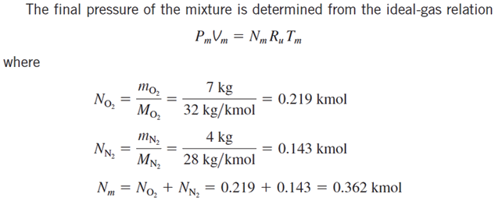

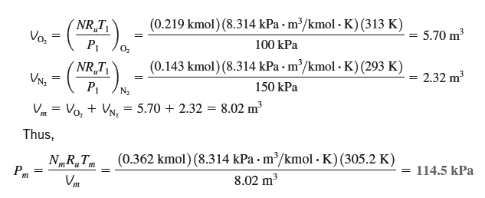

1. The water vapour is calculated as

$$R_{s}=\frac{8.314}{18}=462 J/kg K$$

$$ω=\frac{m_{s}}{m_{A}}=\frac{p_{s}V}{R_{s}T}\frac{R_{a}T}{p_{a}V}=\frac{0.287}{0.462}\frac{p_{v}}{p_{a}}$$

$$ω=0.622\frac{p_{v}}{p_{a}}=0.622\frac{p_{v}}{p-p_{v}}$$

and

$$ω=0.622\frac{1.17}{101.3-1.17}=7.3 g/kg$$

1. a) and c)
2. The water-vapour pressure of saturated air at 30oC is 4.241kPa. Since relative is 60%RH the water-vapour pressure of air is 0.6 (4.241 kPa) = 2.545 kPa. The specific humidity is
$$W=0.622\frac{2.545}{101.3-2.545}=16 g/kg$$

3. From tables: $p_{sat}=3.1698$ kPa $h_{g}=2546.5$ kJ/kg $c_{p}=1.005$ kJ/kg.K

(a) The partial pressure of dry air is:

$$p_{v}=\left(RH\right)p_{sat}=\left(0.75\right)3.1698$$

$p_{a}=p-p_{v}=100-2.38=97.62$ kPa

(b) The specific humidity of air is

$$ω=0.622\frac{p_{v}}{p-p_{v}}=0.622\frac{2.38}{100-2.38}=0.0152 kg/kg$$

(c) the enthalpy per unit mass of the dry air

$h=h_{a}+ωh_{v}=c_{p}T+ωh_{g}=1.005\left(25\right)+0.0152\left(2546.5\right)=63.8 kJ/kg$ where

$$h_{g}≈2500.9+1.82\left(25\right)=2546.4$$

1. RH = 44% ω = 8.0 g/kg h = 46 kJ/kg v = 0.853 m3/kg  
   The enthalpy read from the psychrometric chart is the total enthalpy of the air-vapor mixture per unit mass of dry air. h= H/ma = ha + ωhv
2. (A) and (C)
3. Drawing a horizontal line from 25 oC dry bulb 18 oC wet bulb across to the saturation curve (100%RH), and then a reading the temperature at that point we see that the dew point is 14.2 oC
4. Drawing a sloping line from 25 oC dry bulb 18 oC wet bulb through 13.5C dry bulb, 11.5C wet bulb and continuing to the saturation curve (100%RH), and then a reading the temperature at that point we see that the apparatus dew point is 7 oC.
5. At 25 oC dry bulb 18 oC wet bulb the RH is 50%,  
   At 13.5C dry bulb, 11.5C wet bulb the RH is 78%.
6. At 25 oC dry bulb 18 oC wet bulb the moisture content is 10.0gs/kgda.  
   At 13.5C dry bulb, 11.5C wet bulb the moisture content is 7.6gs/kgda.
7. The mass of condensate collected is: = 10.0 – 7.6 = 2.4gs/kgda.
8. At 25 oC dry bulb 18 oC wet bulb the specific enthalpy is is 50.5 kJ/kgda  
   At 13.5C dry bulb, 11.5C wet bulb specific enthalpy is is 33.0 kJ/kgda
9. The amount of heat removed is: = 50.5 – 33.0 = 17.5kJ/kgda
10. Drawing a vertical line from 25 oC dry bulb 18 oC wet bulb down to a moisture content of 7.6gs/kgda.Call this point “B” Then reading the specific enthalpy at “B”gives 44.5 kJ/kgda..The amount of latent heat removed is = 50.5 – 44.5 = 6.0kJ/kgdaThe amount of sensible heat removed is = 44.5 – 33.0 = 11.5kJ/kgda
11. (The ratio of sensible heat removed to total heat removed is 11.5 / 17.5 = 0.66. This value may also be read from the protractor at the right hand edge of the chart. The centre of the protractor is at 25oC, 50%RH.

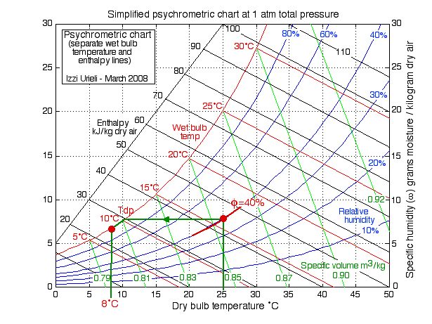  
The air in contact with the windows will become colder until the dew point is reached. Notice that under the conditions of 25°C and 40% relative humidity the dew point temperature is slightly higher than 10°C, At that point the water vapor condenses as the temperature approaches 8°C along the saturation line, and the windows will become foggy.

### Cooling Tower and Evaporative Cooling Analysis

1. At the inlet to cooling tower: DBT = 35oC and WBT = 24oC From psychrometric chart/equations the following values are obtained for the inlet:

* Humidity ratio, Wi = 0.01426 kgw/kgda
* Enthalpy, hi = 71.565 kJ/kgda
* Sp. volume, νi = 0.89284 m3/kgda

At the outlet to cooling tower: DBT = 26oC and RH = 95%

From psychrometric chart/equations the following values are obtained for the outlet:

* Humidity ratio, Wo = 0.02025 kgw/kgda
* Enthalpy, hi = 77.588 kJ/kgda

From mass and energy balance across the cooling tower:

Qc = ma{(ho−hi) − (Wo−Wi)hw} = 100 kW

Substituting the values of enthalpy and humidity ratio at the inlet and outlet of cooling

tower and enthalpy of make-up water in the above expression, we obtain:

ma = 18.97 kg/s, hence, the volumetric flow rate, Vi = ma x νi = 16.94 m3/s (ans.)

Amount of make-up water required mw is obtained from mass balance as:

mw = ma(Wo - Wi) = 18.97(0.02025 − 0.01426) = 0.1136 kg/s = 113.6 grams/s (ans.)

1. 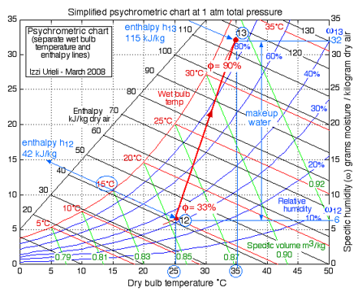

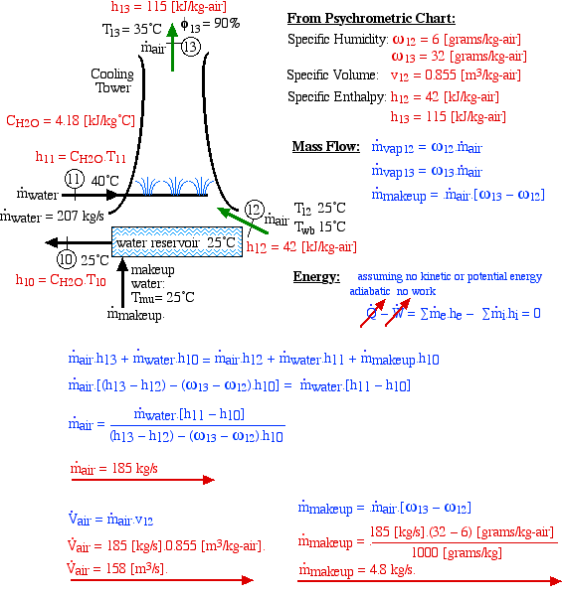

1. 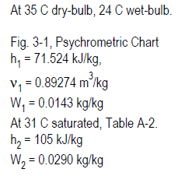 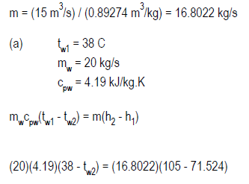

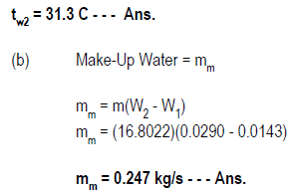

1. (A) and (C)
2. At 1500m, the barometric pressure is equal to **84.436 kPa**. Inlet conditions to the evaporative cooling system are the outdoor conditions: to = 33oC, WBTo = 15oC At these conditions and a barometric pressure of 84.436 kPa, the enthalpy of outdoor air is obtained using psychrometric equations1 as: ho = 46.67 kJ/kgda

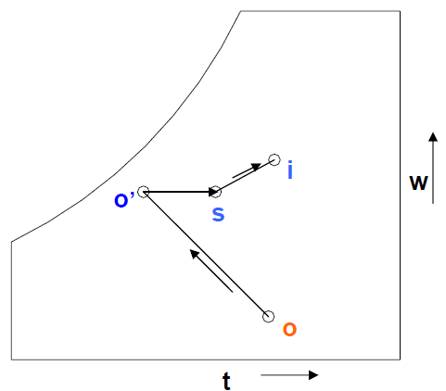

Assuming the evaporative process to follow a constant WBT and hence nearly a constant enthalpy line, ho =ho’ = 46.67 kJ/kgda Applying energy balance for the sensible heating process in the fan (process o’-s) and heating and humidification process through the conditioned space (process s-i), we obtain:

ms(hs – ho’) = 15 = sensible heat added due to fan

ms(hi – hs) = 352 = cooling load on the room

From psychrometric equations, for the inside condition of the warehouse (DBT=27oC and RH = 50%), the enthalpy hi is found from psychrometric equations as: hi = 61.38 kJ/kgda We have two unknowns (**ms and hs**) and two equations (E.1 and E.2), hence solving the equations simultaneously yields:

ms = 24.94 kJ/kg and hs = 47.27 kJ/kgda (Ans.)